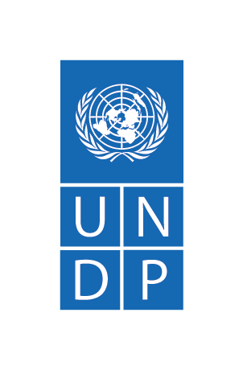

Support to Access to Justice, Security and Human Rights Program in South Sudan.
Project number: 00127551
Quarter Two Progress Report
July 2020
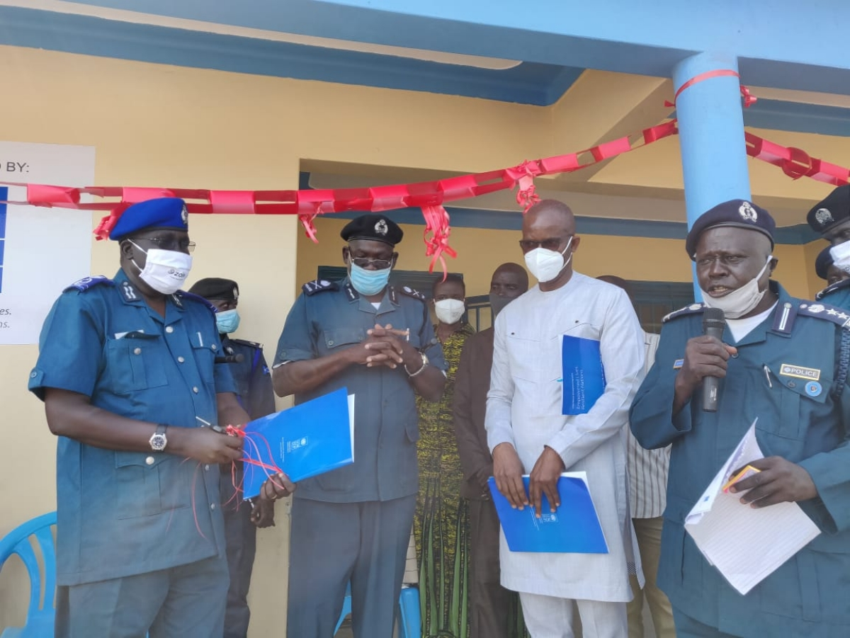
From right: The Deputy Inspector-General of Police and UNDP South Sudan Deputy Representative during the Launch of the Special Protection Unit and Community Policing Unit’s National Coordination Centre in June, 2020. Photo: UNDP

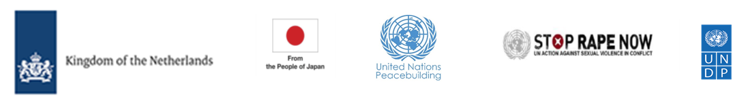
Project Summary | Country: South Sudan  Project Duration: April 2020 to March 2023  Total Program budget: 38,919,057  Annual Budget:4,297,614.26  Cumulative expenditure: 2,306,600.87  Donor Budget in USD Cumulative Expenditures  Netherlands 931,870.60 879,634.99  PBF 1,750,000.01 399,429.35  UNDP 820,000.00 663,072.31  JAPAN 576,439.16 265,849.33  Global Programme 6,497.62 3,170.29  UN Action against sexual violence 212,806.87 95,444.60  TOTAL 4,297,614.26 2,306,600.87  Contact Persons: Kamil Kamaluddeen, PhD  Resident Representative  Tel. +211 920 694101  kamil.kamaluddeen@undp.org  Evelyn Edroma  Chief Technical Advisor/ Program Manager  Tel. +211 920580240  evelyn.edroma@undp.org
Responsible Parties: Ministry of Justice and Constitutional Affairs, Judiciary of South Sudan, South Sudan National Police Service, National Prisons Service of South Sudan, collaborating UN Agencies, and Civil Society Organizations.

Table of Contents
Acronyms 4
1. Executive Summary 5
2. Situation Background 8
3. Progress towards development results 9
3.1 Contribution to longer term results 9
3.2 Progress towards project outputs 9
3.3. Human Interest Story 17
4. Cross cutting issues 17
4.1. Gender results 17
4.2. Partnerships 18
4.3. Environmental Considerations 18
4.4. South to South and Triangular Cooperation 18
4.5. Strengthening national capacity 18
5. Monitoring and Evaluation 20
6. Risk management 21
7. Challenges 21
8. Lessons Learned 21
9. Financial Summary 23

Acronyms
AWP | Annual Work Plan
R-ARCSS | Revitalized Agreement for the Resolution of Conflict in South Sudan
CPD | Country Programme Document
CSO | Civil Society Organizations
ECC | Emergency Call Center
JoSS | Judiciary of South Sudan
MoJCA | Ministry of Justice and Constitutional Affairs
NPSSS | National Prisons Services of South Sudan
PCRC | Police Community Relations Committee
R-TGoNU | Revitalized Transitional Government of National Unity
SGBV | Sexual and Gender-Based Violence
SPU | Special Protection Units
SSNPS | South Sudan National Police Service
UNDP | United Nations Development Programme
UNMISS | United Nations Mission in South Sudan
VTC | Vocational Training Centre

Executive Summary

The Support to Access to Justice, Security and Human Rights Program in South Sudan aims to strengthen the rule of law by providing technical and development support to rule of law actors to increase access to justice and security and promote accountability for serious human rights violations. The program builds on the gains made in the predecessor phase under the project Access to Justice and Rule of Law project whose implementation ended in March 2020. The program contributes to Country Programme Document outcome 1 “Strengthened peace infrastructures and accountable governance at the national, state and local levels.’’
Adopting a sector-wide approach, and guided by international human rights standards and principles, the program focuses on five outputs: i) Justice and security institutions coordinate and deliver accountable, effective and equitable services including gender responsiveness; ii) The most vulnerable people; particularly women, girls, SGBV survivors, IDPs and returnees have increased equal access to a fair and effective justice system; iii) Community security especially in conflict-affected areas is people centered, prevents violence and promotes safety; iv) The national human rights systems promote awareness, respect and provide redress; v) Transitional justice mechanisms effectively address the legacies of human rights violations and root causes of conflict.
UNDP directly implements the program in eight locationsin close collaboration with national partners ensuring that there is national ownership. Under the Global Focal Point for Rule of Law, UNDP coordinates with the United Nations Mission in South Sudan (UNMISS) and United Nations Population Fund (UNFPA) to achieve the project objectives and anticipated results. Other partnerships include the project “Breaking the Cycle of Violence - rehabilitating justice and accountability mechanisms for the transformation of survivors and perpetrators of violent conflict into change agents for peace implemented by UNDP, UNICEF and OHCHR, and the Protecting Women and Girls in South Sudan: Addressing GBV as a Catalyst for Peace between UNFPA, UNDP, UNICEF and UNWOMEN project.
Main achievements during the quarter
The second quarter of 2020 was marked by a rapid rise in COVID-19 infections with 2,021 cases confirmed by the end of June 2020. The program intensified its response to the COVID-19 pandemic with sensitization campaigns and provision of hygiene and personal protection equipment to the Judiciary, Police, Prisons and Ministry of Justice in 6 states, disinfection and decongestion of prison and police facilities.
While observing the Government issued guidelines on COVID19, the program continued providing the Rule of Law institutions with a coordination platform for engagement. In this regard, four rule of law forums were conducted with 67 participants (21 females) with notable results emanating from the meetings being the fast tracking of hearings of rape cases in Wau and a consensus on decongestion of detention facilities to limit the spread of COVID-19. The forums were also used as a platform to sensitize participants on COVID 19 and generate an urgency for the justice sector to get prepared to mitigate and respond to the disease in the justice system.
Efforts to maintain security at the community level and improve the relationship between the police and the community members continued in line with the South Sudan National Police Service (SSNPS) Community Policing Strategy. In this regard, the program facilitated the convening of fifteen Police Community Relation Committees (PCRC) meetings in 7 states i.e. Aweil, Yambio, Torit, Bor, Wau, Bentiu, and Malakal where four new PCRCs were established with 3, 703 participants of which 59 percent were female. In addition to this, the Juba and Wau Emergency Call centers (ECC) also remained operational with the community members calling the police on security related matters such as thefts. The ECC responders also continued to conduct patrols thereby deterring criminal activities as well as apprehending perpetrators and handing them over to the police thereby enhancing peace and security.
To ensure access to justice to GBV survivors, the program continued its efforts of operationalizing the GBV and Juvenile Court and the Special Protection Units National Coordination Office. In parallel, the program partnered with five Civil Society Organizations to establish Justice and Confidence Centers and raise awareness on GBV issues including the dangers of early child marriage as well as proving legal representation to GBV survivors. In this regard, twelve GBV cases have been concluded and 257,227(52 percent female) people reached with messages on GBV which includes from what constitutes GBV and reporting channels. The program also provided specialized training to 40 (11 females) actors in the justice chain on the investigation, prosecution, prevention, response and adjudication of SGBV and related offences in Bor and Aweil. So far 369 GBV case and 82 juvenile cases have been registered in the court. Thirty-eight (38) of the juvenile cases were concluded whereas for GBV cases none has been concluded.
As part of the measures to take services closer to the people in locations where justice institutions and personnel are absent or low, UNDP deployed one mobile court to Kapoeta. The mobile court resolved 60.2 percent of the 73 listed cases and 29 cases are yet to be disposed.
The project continued its support to upgrade and construct Police and Prisons facilities in parts of the country, all of which were carried over from 2019. While the administration blocks in the Lologo Police Station, renovation works at the Gudele block 9 Police Station were completed while construction of the chain link fence in Lologo were ongoing while solar installation efforts for the Lologo and Gudele police station were ongoing. Additionally, support to prison infrastructure was underway with concluded construction at the Terekeka county prisons and Malakal State prison ongoing. Complementary support to prisons through the functioning of Vocational Training Centres (VTCs) continued with 246 inmates continuing their vocational skill training in various field at the Wau and Juba prisons.

Challenges
The effects of the COVID-19 outbreak continued to impact program implementation as well as the justice and rule of law institutions. The program scaled down its work and carried out activities while employing the Government Guidelines. With the impact and spread of Covid-19 continuing, incidents of SGBV increased and crime rates were noted to be on the rise with a 46-percentage rise in crime in Jubek state alone. The continued arrest and detention of suspects is creating a residual upsurge in case backlog due to disrupted justice service delivery. All this is widening the justice gap for already disadvantaged groups such as SGBV survivors and prisoners, threatening to roll back the fragile gains made on criminal and gender justice.
Persistent delays by Government to implement rule of law measures that support accountability mechanisms such as the formation of a truth and reconciliation commission and the operationalization of the GBV and Juvenile court thereby delaying justice for the survivors of GBV as survivors would have the option to pursue justice through the CTRH. UNDP’s call to optimally operationalize the GBV court after its establishment and the training of judges and other relevant actors in 2019, was stalled by further delays from the judiciary despite several engagements.
Lessons learned:
Flexibility during implementation of activities can allow the program to respond to urgent emerging needs: The ability to repurpose part of the annual budget and adjust activities swiftly and flexibly and ensured that the program remains relevant in support of the justice sector. This ensured that the justice sector was accorded the needed support to prepare and adapt to the COVID19 pandemic within the broad remit of the project outcomes.
In adjusting the programming to the COVID19 context, there is a unique opportunity for South Sudan to promote virtual court sessions even though the country does not have the facilities available to operate court sessions digitally. The project will promote remote hearings for the application of bail by pretrial detainees whose release will decongest places of detention. Lessons learnt will be critical for piloting an e-justice system in Juba.

Budget
The annual project budget is US$4,297,614.26. The total expenditure for the quarter is US$2,306,600.87 translating into 53.67% delivery.

Situation Background

As South Sudan recovers from several years of civil war and political crises in 2013 and 2016, it continues to rebuild a justice and policing system weakened by conflict and instability. Signed in 2018, the Revitalized Agreement on the Resolution of Conflict in South Sudan (R-ARCSS) adds responsibility on the Revitalized Transitional Government of National Unity (R-TGoNU) to tackle the country’s rule of law deficits. The formation of the R-TGoNU in February 2020 marked the beginning of South Sudan’s 36-month transitional period which is expected to secure the country’s path towards lasting peace for the close to 13 million South Sudanese people. Within the transitional period, the R-TGoNU should make a permanent constitution, pursue reconciliation, healing and structural reforms that include a judicial review and security sector reforms.
The formation of the Transitional Government of National Unity in February brought renewed hope for lasting peace. With the outbreak of COVID19 and its rapid spread in the second quarter, implementation of the peace agreement stalled as the pandemic impacted an already weak justice system that is underfunded with inadequate presence, staff, infrastructure, equipment, and supplies. It has further disrupted the delivery of justice services, and contributed to increased crime, sexual and gender-based violence and case backlog in courts. Despite this, the program continued to implement some of its core rule of law activities while complying with the WHO and Government guidelines aimed at preventing the spread of the virus. Most efforts were refocused towards increasing the preparedness of the justice actors to respond to the pandemic within the broad remit of the project outcomes of strengthening the capacities of justice and security institutions to ensure access to justice and safety, especially for vulnerable groups and SGBV survivors using a sector wide approach. The program worked closely with the government, UN agencies, and civil society organizations to achieve this.
The Support to Access to Justice, Security and Human Rights Program in South Sudan aims to build the capacities and mechanisms of rule of law institutions and increase the demand for access to justice at the community level through rights-based interventions. The project is aligned with: the rule of law pillar in the South Sudan Vision 2040: “Promoting supremacy of the rule of law and separation of powers, recognition of human rights and fundamental freedoms, justice and equality for all, and promoting accountability and transparency in governance, and the 2019 -2021 UNDP South Sudan Country Programme Document (CPD) outcome 1: “Strengthened peace infrastructures and accountable governance at the national, state and local levels.’’
The program maintains the sector wide approach in the implementation of these measures while paying attention to ensuring that the initiatives are nationally owned, rights based and gender responsive. In keeping to the spirit of coordination with other United Nations entities in South Sudan, the Access to Justice project worked through the Global Focal Point for Rule of Law and other platforms to deliver coordinated assistance to national justice partners including the Ministry of Justice and Constitutional Affairs and the Judiciary.

Progress towards development results

Contribution to longer term results
Interim Cooperation Framework (ICF)/Country Programme Document (CPD) Outcome 1: “Strengthened peace infrastructures and accountable governance at the national, state and local levels.”
Summary achievements based on CPD Outcome One targets
CPD output indicator | Progress to date | Status
Four thousand GBV cases (50% women) reported to authorities receiving judgment in the formal justice system. (baseline 1,324 (58% women) | 558 (82percent female)  Cumulative number: 1,882 (68 percent female). | Ongoing
Ten police and community relationship committees established and operational at community level. (baseline 5) | 45 new PCRCs have been established and are operational in 2020.  Cumulative number: 50. | Ongoing
Five thousand indigent persons (1,500 females, 3,500 male) provided with legal aid services, disaggregated by sex. (Baseline: 220 (68 female, 152 males. | 1,952 (901 female)  Cumulative number:  2,172 (969 female). | Ongoing
Two thousand SGBV survivors (800 females, 1200 males) benefitting from victim redress mechanisms, including on transitional justice. (Baseline: 125 (50 females, 75 males) | 1,208 (881 female)  Cumulative number:1,331 (981 female). | Ongoing
Overall status |  | Ongoing

Progress towards project outputs
Project Output 1: Justice and security institutions coordinate and deliver accountable, effective and equitable services including gender responsiveness
Summary achievement against 2020 Annual Work Plan (AWP) target
Indicator (as they appear in the AWP) | Indicator Target (2020) | Summary achievement during the quarter | Status:
1.1. Number of supportive actions taken to ensure an inclusive process to develop a permanent constitution. | 12 supportive actions taken | 6 supportive actions taken | Ongoing
1.2. Number of supportive actions taken in support of justice sector reforms | 6 supportive actions taken | 1 supportive action taken | Ongoing
1.3. Number of supportive actions taken in support of security sector reforms | 6 supportive actions taken | 1 supportive action taken
1.4. Number of laws reviewed and revised. | 5 | 0  Recruitment of a consultant to review the priority laws underway. | Ongoing
1.5. Number of Rule of Law forums held. | 48 | 4 | Ongoing
1.6. Number of female officers recruited in the police service. | 300 | Scheduled for the second half of the year | Pending
1.7. No of institutions disinfected (Police stations, prisons, police posts) following COVID19 outbreak. | 50 | 50 | Ongoing
 | Overall status |  | Ongoing

Description of Results
Project Output one: Justice and security institutions coordinate and deliver accountable, effective and equitable services including gender responsiveness

Indicator 1.1. Number of supportive actions taken to ensure an inclusive process to develop a permanent constitution. (Baseline 0 actions taken).

The R-TGoNU formed in February 2020 is mandated to develop and adopt a permanent constitution within the 36-month transitional period, a process which the program is supporting. In this regard, the program participated in six inter-stakeholder discussions involving UNDP, UNMISS, International Institute for Democracy and Electoral Assistance (IDEA) , Reconstituted Joint Monitoring and Evaluation Commission (RJMEC) and donors to define realistic and effective next steps towards preparations for the permanent constitution-making process in light of the constraints imposed by COVID19 pandemic. Follow up meetings and consultations will be held to determine the way forward in light of the COVID-19 pandemic.

Indicator 1.2. Number of supportive actions taken in support of justice sector reforms.
(Baseline 0).

The formation of the R-TGoNU in February 2020 set provisions for the R-TGoNU to make structural reforms in the justice sector a process which the program will be supporting. To help identify the areas that need reform in the justice sectors, the program is in the process of recruiting a consultancy firm to conduct the public perception survey to establish justice gaps which will then inform the project on the areas of intervention.

Indicator 1.3. Number of supportive actions taken in support of security sector reforms.
(Baseline 0).

The formation of the R-TGoNU in February 2020 set provisions for the R-TGoNU to make structural reforms in the security sector a process which the program will be supporting. To set off implementation of the security sector reforms, UNDP participated in a meeting with the Inspector General of Police where the new police structure that is in line with the reviewed Police Act proposed in the R-TGoNU was shared. Under the new structure, the Police Development Committee is at the apex as the governing policy making body, with the Inspector General of Police (IGP) as a member and the Chief Executive of the South Sudan National Police Service.
Other notable changes under the new structure include, the creation of Special Protection Unit (SPU) and Community Policing Unit (CPU) as separate directorates to pay special attention to GBV cases and community security. The IGP also communicated plans to launch the Strategic Plan and the Police Structure to pave way for implementation of the Police component in the R-ARCSS.

Additionally, the program also continues to support institutional development through continued constructions, renovations and provision of equipment. In this regard, the program continued to support renovations of the various institutions; renovations of the Lologo and Gudele police stations was completed while Malakal state prisons Vocational Training Center (VTC), Terekeka county female prison, construction of wall fence at Yei county prison and the construction of office block at Juba Juvenile Reformatory School is ongoing. Support to prison infrastructure development in prison and police facilities ensures that minimum human rights standards are maintained while support to VTCs provides inmates with an opportunity to develop skills that will help them earn a livening following release thereby decreasing the chances of recidivism.

Indicator 1.4. Number of laws reviewed and revised. (Baseline 11)
There were no legislative reviews conducted in this quarter. However, the program is in the process of concluding the recruitment of an international consultant to review six priority laws that were identified in consultation with the Law Review Commission and the Ministry of Justice and Constitutional Affairs. The laws include the Penal Code Act, Code of Criminal Procedure Act, Civil Procedure Act, Evidence Act, Legal Aid Act, Interpretation of Laws Act.
Indicator 1.5. Number of Rule of Law forums held. (Baseline 48)
The program also continued to facilitate the Rule of Law Forums as they provide coordination platform for Rule of Law institutions. In this regard, four Rule of Law meetings were conducted with 67 participants (21 females) with notable actions emanating from the meetings being the fast tracking of hearings of rape cases in Wau, the decisions to decongest prisons to limit the spread of COVID19. The forum was also used by agencies to coordinate their responses to the COVID19 pandemic.

Indicator 1.6. Number of female officers recruited in the police service. (Baseline 1,262)
The R-TGoNU provides for gender equality and women’s empowerment during the transitional period a process that the program plans to support. In this regard, the program plans to support the SSNPS by providing professional training for female police officers recruited in the SSNPS in the second half of the year.

Indicator 1.7. No of institutions disinfected (Police stations, prisons, police posts) (Baseline 0)
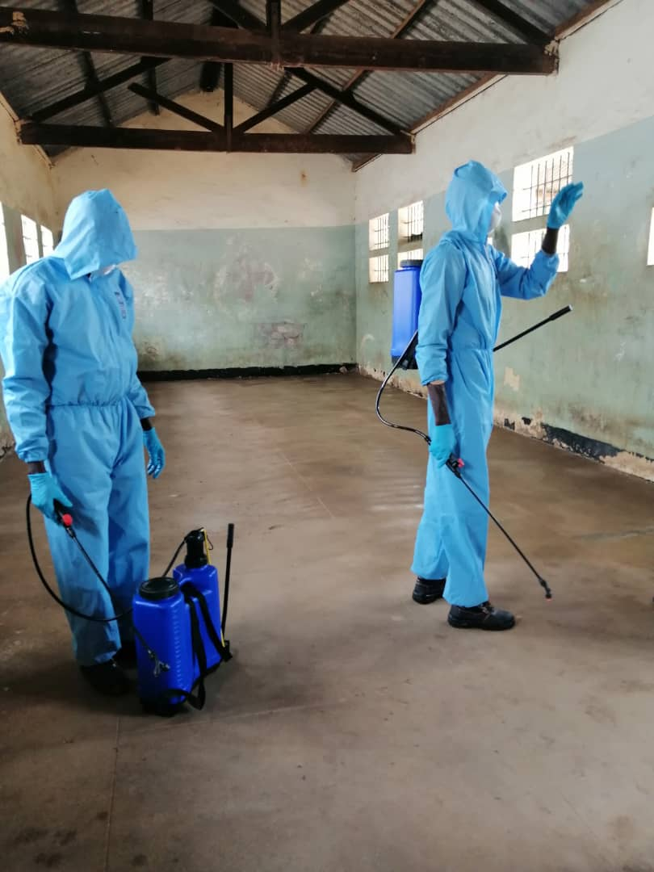
In response to the COVID19 pandemic, the program provided institutional support to the South Sudan National Police Service (SSNPS), National Prison Service of South Sudan (NPSSS), Ministry of Justice and Constitutional Affairs (MOJCA) and Judiciary of South Sudan (JoSS). In this regard, 50 institutions were disinfected including: 23 police stations, 14 police posts and 13 prisons. Other support provided included provision of 4, 500 liters of liquid soap, 750 liters of hand sanitizer, 2,235 face masks, 3,000 pairs of gloves, 500 liters of disinfecting liquid and 12 thermo-Gun to the Judiciary, Police, Prisons and Ministry of Justice in Juba Aweil, Bor, Torit, Yambio and Wau. 1, 000 public handwashing stations were also installed at the entrance of all their buildings. As a result, there was reduced risk of contracting or spreading of COVID within the mentioned institutions thereby in turn also protecting the general populace. The program also partnered with UNMISS to develop two sets of Preparedness and Response Procedures and guidelines, improving the Police and Prisons’ capacity to plan, prepare and respond to COVID-19. The guidelines outline measures on operational preparations, hygiene practices, social distancing, limiting transmission, infection control and screening. The quick issuance of guidelines, coupled with training for senior police and prisons officials, is supporting the safety and protection of prisoners and pretrial detainees.
Picture 1: Picture shows disinfection of the Juba Central Prison in April 2020. Photo UNDP.
The program also supported decongestion efforts in police and prison facilities to limit the impact of COVID19. In this regard, 1,418 (151 female) inmates were released from police and prison facilities from 5 prisons and 13 police detention facilities in Juba, Aweil, Bor, Torit, Yambio and Wau. An additional 717 pretrial detainees in Juba Central prison await judicial decision for release from prison on bail. 87 convicted prisoners with less than 6 months are also being considered for parole. Additionally, in support of the monitoring of the human rights situation during the COVID-19 pandemic, the program has partnered with the South Sudan Human Rights Commission (SSHRC) and South Sudan Democratic Engagement Monitoring and Observation Programme (SSuDEMOP) to monitor instances of Human Rights violation and to analyze the impact of enforcing the Government issued measures on the rights of people living in South Sudan especially the most vulnerable. Read detailed COVID19 report here.

Project Output 2: The most vulnerable people; particularly women, girls, SGBV survivors, IDPs and returnees have increased equal access to a fair and effective justice system

Indicator | Indicator Target (2020) | Summary achievement during the quarter | Status:
2.1. Number of indigent persons who have received legal aid from CSO. | 2000 (30% female) | 295 (66% female) | Ongoing
2.2. Percentage of reduction in case backlogs. | 75% | 60.2% | Ongoing
2.3. Number of traditional leaders trained on human rights and gender equality developed. | 200 (30% female) | To be conducted in second half of the year. | Pending
 | Overall status |  | Ongoing

Indicator 2.1. No of people who have received legal aid from CSO. (Baseline 11,893)
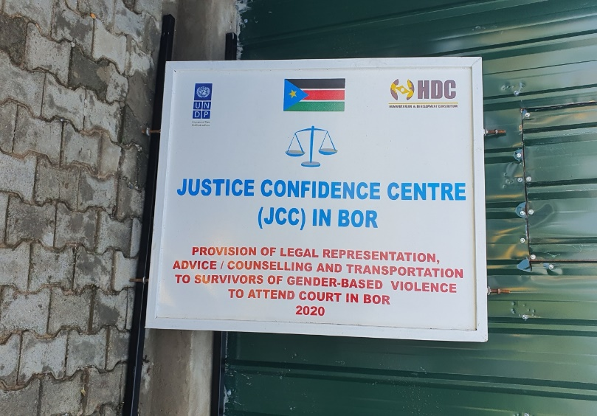
Two hundred and ninety-four persons (66 percent female) have received legal aid provided through four Justice and Confidence Centres (JCCs) established by five partner CSOs implementing in Bor and Aweil. The CSOs have also been raising awareness on human rights and GBV in Bor and Aweil and have reached 257,227 (52 percent female) with messages on GBV including the dangers of early child marriage in Aweil and Bor. In parallel, to ensure professional handling of GBV cases, the program provided specialized training to investigators, social workers, chiefs, prosecutors, and judges on investigation, prosecution, prevention, response and adjudication of SGBV and related offences in Aweil and Bor. In this regard, the project trained 40 (11 females) in Bor with participants reporting and 78 percent and 80 percent increase in knowledge on the subject in Aweil and Bor respectively thereby equipping them to handle GBV cases professionally and in line with human rights standards.
Picture 2: Partner CSO signpost detailing the services they are providing through UNDP support
So far, 369 GBV case and 82 juvenile case have been registered in Gender Based Violence Court in Juba with 38 juvenile cases concluded. The program continued to support the operationalization of the Gender Based Violence (GBV) and Juvenile Court in Juba by addressing the logistical challenges experienced by the Judiciary and the Prison Service in executing their daily functions. This was achieved through the repair of two vehicles that are being used to facilitate the transportation of inmates from prison to court as well as staff including justice to the courts a move that is expected to expedite trial.

Indicator 2.2. Percentage of reduction in case backlogs. (Baseline 75%)
A mobile court comprising of two judges, two prosecutors and two defence attorneys were deployed to Kapoeta for a period of thirty days resolved 60.2 percent of the backlogged cases. The team resolved 44 out of the 73 listed backlog cases listed with 17 convictions (one GBV case) 27 acquittals and 29 pending cases. Plans are underway to deploy four Mobile Courts to Yambio, Terekeka, Malakal and Bentiu where the limited presence of justice actors is creating case backlog and prison congestion.
Indicator 2.3. Number of traditional leaders trained on human rights and gender equality (Baseline: 465 (19.6% female).
During the reporting period no training was conducted. Training is scheduled fo rteh second half of the year as the program recognizes the vital role that traditional leaders play in resolving civil matters especially at the community level where formal justice services might be unavailable. The traditional leaders will be trained on basic principles of human rights and gender equality to ensure that they have the right skills to administer justice in accordance with international human rights standards.

Project Output 3: Community security especially in conflict-affected areas is people centered, prevents violence and promotes safety

Indicator | Indicator Target (2020) | Summary achievement during the quarter | Status:
3.1. Number of SPUs established and operationalized to respond to SGBV and child marriage | 10 | 1 | Ongoing
3.2. Number of PCRC meetings held. | 72 | 15 | Ongoing
3.3. Number of calls responded to by Emergency Call Centers (ECC) | 2000 | 501 | Ongoing
 | Overall status |  | Ongoing

Indicator 3.1. Number of SPUs established and operationalized to respond to SGBV and child marriage. (Baseline 1)
To provide accessible entry points for reporting GBV cases the program supported the establishment and operationalization of the SPU national coordinating office in Juba following minor renovations to the administration blocks and motorizing the existing borehole. The national coordination office will coordinate the six states SPUs to ensure investigation, prosecution of and judicial decisions for all cases of violence against women, children and other vulnerable groups, involving child abuse and neglect.

Indicator 3.2. Number of PCRC meetings held. (Baseline 117)
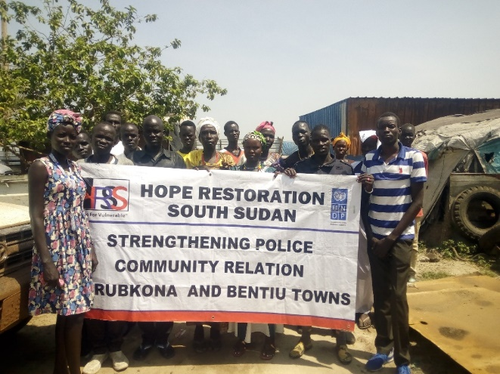
Fifteen PCRC meetings were conducted in 7 states i.e. Aweil, Yambio, Torit, Bor, Wau, Bentiu, and Malakal with 3,703 participants of which 59 percent were female. Four new PCRCs were also established and four community watch groups were established in Bentiu and Rubkona. PCRCs enhance police community relations and increase civilian’s confidence in formal justice and security system. The platform provides an opportunity for members to work in partnership with the police to combat crime. The significant role played by the PCRCs was noted in Malakal where community policing was introduced in the second quarter. Community members and police reported high rates of distrust amongst them with the former accusing the police of abuse of authority. The police raised concerns over many civilians having firearms and community members handling security related issues without involving them. In the introductory meeting the PCRC members promised to work together with both parties as they forge a way forward in ensuring community security.
Picture 3: Participants in a PCRC meeting pose for a photo in Bentiu. Photo@HRSS.
Indicator 3.4. Number of calls responded to by ECC. (Baseline: 27,220).
Five hundred and one (501) people accessed the ECCs in Juba and Wau on various issues, such as theft, grievous hurt, armed robbery and GBV. As a result, responders arrested 386 perpetrators involved in criminal activities and handed them over to the concerned police divisions. The ECC responders also conduct patrols to help deter criminal activities.
Project Output 4: The national human rights systems promote awareness, respect and provide redress

Indicators | Indicator Target (2020) | Summary achievement during the quarter | Status:
4.1. Support for the development of the strategic plan for the South Sudan Human Rights Commission (SSHRC) | Developed | Planned for the second half of the year | Pending
4.3. Juvenile reformatory center constructed and furnished in line with human rights standards. | 1 | In progress | Ongoing
 | Overall status |  | Ongoing

Indicator 4.1. Develop strategic plan for the SSHRC. (Baseline Not developed)
During the reporting period, the program had not started supporting the SSHRC to develop the strategic plan. The program plans to upscale its support to the SSHRC. This will be achieved by supporting the development of the SSHRC strategic plan that will set the overall goals of the commission and provide a plan to achieve them. In addition to this, the program will conduct a capacity needs assessment to map out priority areas of intervention and the capacity building approach.

Indicator 4.2: Juvenile reformatory center constructed and furnished in line with human rights standards, (Baseline 1)
In support of the institutional reforms in the justice system and to provide rehabilitation for juveniles in conflict with the law, the program will be constructing, rehabilitating and furnishing juvenile reformatory centers in line with Human Rights standards. In this regard, plans for the construction for the Aweil Juvenile reformatory centre are in high gear with preparatory steps concluded including establishing that the design is based on a capacity of a hundred juveniles, issuing of a bill of quantity and a contractor identified. The construction is set to begin in the third quarter. Preparatory actions for the renovation of the Central Equatoria State Juba Reformatory Centre is in progress.
Further, to equip inmates with skills that will help them address their immediate needs upon release 246 inmates continue to receive skills training across twelve trades in the Wau and Juba VTC.
Project Output 5: Transitional justice mechanisms effectively address the legacies of human rights violations and root causes of conflict

Indicator | Indicator Target (2020) | Summary achievement during the quarter | Status:
5.1. National strategy on Transitional Justice developed | Developed | 1 action taken | Ongoing
5.2. Number of people reached during outreaches and media campaigns on Transitional Justice. | 200,000 | Planned for the second half of the year | Ongoing
 | Overall status |  | Ongoing

Indicator 5.1. National strategy on Transitional Justice developed. (Baseline: Not developed).
Preparatory work for the development of the National Strategy on Transitional Justice was conducted. A meeting was held with the Minister of the Ministry of Justice and Constitutional Affairs to identify areas in which the program can support the formation of Government led transitional justice mechanisms with follow up meetings scheduled for the second quarter. Additionally, the program plans to engage stakeholders to map a way forward on developing a National Strategy on Transitional justice.

Indicator 5.2. Number of people reached during outreaches and media campaigns on Transitional Justice. (Baseline: 52,172).

There were no public outreach programs on transitional Justice conducted. The program plans to partner with CSOs to launch community outreach programmes on transitional justice

Human Interest Story
Provision of legal aid to the vulnerable.
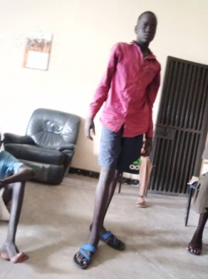
Meet Kuol Mayen Awan, a 15-year who was sentenced to jail on a murder charge in Bor. Kuol shares his story that led to his arrest and subsequent trial and sentencing.
“One evening I went out grazing cattle with my three friends in the outskirts of Bor town. Upon our return, I was offloading a light machinegun with the assumption that the gun didn’t have any bullets, I pulled on the trigger and accidentally shot my friend who died shortly afterwards. I was arrested on the same day and court proceedings begun thereafter. I was tried for murder and sentenced to ten years in prison.” This is the maximum sentence stipulated for a murder charge when a juvenile is charged.
During prison visitation the boy shared his story with the UNYMPDA lawyer who appealed his case and the charge was reduced to manslaughter and Kuol was sentenced to five years in prison. Asked about the new sentence Kuol said” I did not intend to kill my best friend, and it still weights heavily on my conscience. I’m happy that the jail term has been reduced to five years. I hope I can get an opportunity to continue with school as that would help me build my future.” He thanked UNYMPDA and UNDP for the support he had received as this had brought renewed hope in his life. The interview ends with his appeal for community members to stop carrying guns as accidents can easily happen and people might end up in a similar situation that he now finds himself in
Picture 4: Kuol poses for a photo inside the prison following the new sentence.

Cross cutting issues

Gender results
Gender results | Evidence
Gender result 1: Increased awareness on access to legal aid services to survivors of SGVB. Through partnerships with 5 CSOs, the program has been providing legal aid for GBV survivors as well as raising awareness on GBV and sensitizing the communities on it being a criminal offence and it being a violation of human rights. To this effect, the CSOs have reached 257,227 (52 percent female) and twelve GBV cases have been concluded in court. | Evidence 1: UNDP reports.
Gender result 2: Operationalization of the National Special Protection Unit Coordination Office to ensure investigation, prosecution and judicial decisions for all cases of violence against women, children and other vulnerable groups, involving child abuse and neglect. | Evidence 2: Project reports

Partnerships

The program partnered with CSOs to deliver legal aid services to vulnerable and disadvantaged groups and to raise awareness on GBV. In addition to this the program continued supporting community policing at the grassroots level to increase security. Partnerships with CSO have proven to be successful in ensuring the program delivers on its commitments as they are flexible, and able to reach areas that UNDP does not have a presence and have proven to be effective at working in the communities.
As part of efforts to foster complementarity and minimize duplication of activities, the program is contributing to integrated UNDP programming with the Peace and Community Cohesion Project to implement the PBF supported project, Gender mainstreaming in Security Sector Reform.
Likewise, joint projects such as the project “Breaking the Cycle of Violence - rehabilitating justice and accountability mechanisms for the transformation of survivors and perpetrators of violent conflict into change agents for peace implemented by UNDP, UNICEF and OHCHR, and the Protecting Women and Girls in South Sudan: Addressing GBV as a Catalyst for Peace between UNFPA, UNDP, UNICEF and UNWOMEN project catalyse UN partnerships.

Environmental Considerations
The projects procurement and construction or rehabilitation of rule of law institutions include environmental sensitivity analysis (as per UNDP policy) and the supply of renewable energy. For example, plans are underway to install PV solar system to the recently renovated of the Lologo and Gudele police stations to ensure power availability for sustainability purposes and in regard to environmental considerations.

South to South and Triangular Cooperation

No South to South and Triangular Cooperation was undertaken in the quarter.

Strengthening national capacity

Results achieved | Institution | National capacity strengthened
- Improved operational ability of SSNPS and NPSSS through infrastructure construction and renovation. | SSNPS and NPSSS | Strengthened institutional capacity of the SSNPS through ongoing renovations to Malakal and Terekeka prison and Lologo police station and completed renovation of the Gudele police post.
- Improved technical capacity of investigators, social workers, chiefs, prosecutors, and judges on to ensure professional handling of GBV cases | JoSS, SSNPS, MoGSW | Capacity of actors to handle GBV cases in compliance to South Sudan Laws and Human rights strengthened

Monitoring and Evaluation
Key M&E activity | Key outcomes/ observation | Recommendation | Action taken
Program Review by the Program Board | The 2019 progress report was presented, and the members were apprised of the project achievements, challenges and lessons learnt in 2019.  The new programme document for the new phase (Previous phase ended on 31st March 2020) was presented and different components and planned areas of intervention were elaborated on.  The disposal and transfer of project Asset (vehicle) purchased under the Emergency Support to conflict affected people and Vulnerable Groups in Juba and Bor | -The board accepted the 2019 annual report.  - The new programme document was endorsed.  - The board approved the transfer of the vehicle to the Police as per UNDP policy and procedures. | - Implementation of the new programme would begin.  -UNDP process and procedures would be followed for the disposal of the project asset.
Reporting from UNDP field staff | UNDP maintains a field presence in six locations through the Rule of Law Officers and the Law Enforcement Advisors who carry out direct implementation and obtain data and information to help track progress and feed into project reporting process. The field staff also play a vital role of monitoring partner CSOs | - Encourage timelier and more detailed reporting on project results and to monitor partner CSOs implementation. | The field staff were involved during the CSO selection process as they have firsthand knowledge on the CSOs operating in their specific locations. The CSO workplans were also shared with the field staff to guide their monitoring plans. The M&E Specialist regularly follows up on progress of implementation by reviewing reports.
Remote monitoring of CSO | Ensure that CSOs are implementing their activities as per the signed responsible party agreements. | - Encourage timelier and quality reporting on project results that are carried out by partners CSOs. | During the signing of grant agreements with CSOs, the project outlined the reporting responsibilities. CSOs were provided with reporting templates and they are provided feedback on the monthly reports and guided on reporting requirements and content.

Risk management
Risks | Mitigation Measures
Changing political environment particularly disagreement amongst R-TGoNU parties and escalation of armed violence at the national or in project locations. | Regular contextual analysis in program locations and establishment of relations with local authorities and state/non-state actors to sustain program implementation beyond any political changes. Collaborate with UNMISS Political Affairs Division and IGAD/AU/Troika interventions.
Capacity of national and local stakeholders and implementing partners and resistance to reform-oriented change | Provision of technical advisory support, and peer mentoring, that incentivize collaborative working relationships and skills exchange.
Health risk caused by the COVID19 Pandemic | The program has slowed the implementation of program activities to reduce the risk of exposure. Within its broad outcomes, the program refocused its efforts towards increasing the preparedness of the justice actors to respond to the pandemic. Staff are telecommuting with virtual meetings being conducted to ensure business continuity.

Challenges
Persistent delays by Government to implement rule of law measures that support accountability mechanisms such as the formation of a truth and reconciliation commission and the operationalization of the GBV and Juvenile. UNDP’s call to operationalize the GBV court after its establishment and the training of judges and other relevant actors in 2019, was stalled by further delays from the judiciary despite several engagements.

Due to the COVID19 pandemic, the incidents of SGBV against women is increasing but go unaddressed. Crime is increasing with a 46-percentage rise in crime in Jubek state alone. The continued arrest and detention of suspects is creating a residual upsurge in case backlog due to disrupted justice service delivery. All this is widening the justice gap for already disadvantaged groups such as SGBV survivors and prisoners, threatening to roll back the fragile gains made on criminal and gender justice.

Lessons Learned
- Flexibility during implementation of activities can allow the program to respond to urgent emerging needs: The ability to repurpose part of the annual budget and adjust activities swiftly and flexibly in support of the justice sector to prepare and adapt to the COVID19 pandemic within the broad remit of the project outcomes ensured that the program remains relevant.

- In adjusting the programming to the COVID19 context, there is a unique opportunity for South Sudan to promote virtual court sessions given even though the country does not have the facilities available to operate court sessions digitally. The project will promote remote hearings for the application of bail by pretrial detainees whose release will decongest places of detention. Lessons learnt will be critical for piloting an e-justice system in Juba.

Financial Summary

Outputs / Activity Result |  | Annual Budget (Jan – Dec 2020) | Expenditures (Jan - March 2020) | Expenditures (April - June 2020) | Cumulative Expenditures (Jan - June 2020) | % Expenditure (Cumulative)
 |  | A | B | C | D=B+C | D/A*100
Output 1: Functions and capacity of rule of law institutions enabled to deliver accountable, effective and equitable justice services.
AR 1.1 | Capacity of rule of law institutions to draft and review key legislation improved, with particular attention to human and women’s rights. | 610,326.67 | 346,983.73 | 329,692.97 | 676,676.70 | 110.87%
AR 1.2 | Mobile court established to reduce case backlog and arbitrary detention. | 49,000.00 | 24,353.72 | 23,624.36 | 47,978.08 | 97.91%
AR 1.3 | National prisons service empowered to care and rehabilitate inmates in line with international standards. | 353,628.75 | 152,385.12 | 197,484.13 | 349,869.25 | 98.94%
AR 1.4 | Unified case management system established through coordination between rule of law institutions for timely processing of cases and reduction of case backlog. | 4,251.88 | 3,724.70 | 0.00 | 3,724.70 | 87.60%
AR 1.5 | Consistent application of human rights standards by customary leaders facilitated. | 59,997.62 | 79.19 | 54,563.16 | 54,642.35 | 91.07%
AR 1.6 | SURGE | 100,000.00 | 0.00 | 0.00 | 0.00 | 0.00%
AR 1.7 | UN ACTION against sexual violence in conflict in South Sudan | 212,806.87 | 76,812.69 | 18,631.91 | 95,444.60 | 44.85%
AR 1.8 | RBA Response to COVID-19 | 200,000.00 | 0.00 | 85,361.49 | 85,361.49 | 42.68%
Output 1 Sub-total |  | 1,590,011.79 | 604,339.15 | 709,358.02 | 1,313,697.17 | 82.62%
Output 2: Measures in place and implemented in the rule of law sector to prevent and respond to sexual and gender-based violence.
AR 2.1 | Legal aid providers empowered to deliver legal services to vulnerable population groups, including SGBV survivors. | 47,960.00 | 3,551.37 | 43,828.78 | 47,380.15 | 98.79%
AR 2.2 | Strengthened referral paths for vulnerable people to increase protection and opportunities for legal redress. | 74,640.00 | 2,663.36 | 10,209.00 | 12,872.36 | 17.25%
AR 2.3 | Create an enabling environment for safe and dignified returns through deployment of a professional police force (including the Joint Integrated Police). | 0.00 | 0.00 | 0.00 | 0.00
Output 2 Sub-total |  | 122,600.00 | 6,214.73 | 54,037.78 | 60,252.51 | 49.15%
Output 3: Human rights and transitional justice mechanisms strengthened to monitor and respond to the promotion and protection of citizen's rights.
AR 3.1 | Strengthen mechanisms for oversight and monitoring of the promotion and protection of human rights in South Sudan. | 0.00 | 0.00 | 0.00 | 0.00
AR 3.2 | Support the establishment of transitional justice, peace and reconciliation mechanisms in accordance with Peace Agreement and informed by international standards. | 0.00 | 0.00 | 0.00 | 0.00
AR 3.3 | Project management support | 258,563.30 | 179,030.31 | 88,342.20 | 267,372.51 | 103.41%
AR 3.4 | Protecting Women and Girls in South Sudan: Addressing GBV as a catalyst for Peace | 350,000.00 | 205,975.00 | 64,182.86 | 270,157.86 | 77.19%
Output 3 Sub-total |  | 608,563.30 | 385,005.31 | 152,525.06 | 537,530.37 | 88.33%
Output 4: JSB 2018 & JSB 2019(Japan)
JSB 2018 | Support to community stability | 191,917.16 | 184,889.97 | 6,862.00 | 191,751.97 | 99.91%
JSB 2019 | Support to Safe, Dignified and Voluntary Returns for Durable Peace  Project Number: | 384,522.00 | 0.00 | 74,097.36 | 74,097.36 | 19.27%
Output 4 Sub-total |  | 576,439.16 | 184,889.97 | 80,959.36 | 265,849.33 | 46.12%
Output 5: Breaking the Cycle of Violence - rehabilitating justice and accountability mechanisms
for the transformation of survivors and perpetratars of violent conflict into change agents for peace (UNDP)
AR 5.1 | Improved access to justice in the target communities of Aweil, Bor/Pibor. Bentiu and Juba | 20,000.00 | 0.00 | 0.00 | 0.00 | 0.00%
AR 5.2 | Fair trials/detention provided for children and youth (survivors, perpetrators, and children who are in conflict with the law alike – male and female below 24) of the target communities in Aweil, Juba, Bor and Bentiu. | 296,546.61 | 0.00 | 3,643.20 | 3,643.20 | 1.23%
AR 5.3 | Enhanced capacity of justice actors in Aweil, Juba, Bor and Bentiu. | 95,559.00 | 30,637.00 | 18,413.57 | 49,050.57 | 51.33%
AR 5.4 | Project management | 242,100.00 | 0.00 | 36,606.94 | 36,606.94 | 15.12%
AR 5.5 | Indirect support costs | 45,794.39 | 2,144.59 | 2,817.50 | 4,962.09 | 10.84%
Output 5 Sub-total |  | 700,000.00 | 32,781.59 | 61,481.21 | 94,262.80 | 13.47%
Output 6: Breaking the Cycle of Violence - rehabilitating justice and accountability mechanisms
for the transformation of survivors and perpetratars of violent conflict into change agents for peace (OHCHR)
AR 6.1 | Built/strengthened local networks of survivors for peace dialogues with local communities and political elites in the target communities of Aweil, Bor and Bentiu. | 598,000.00 | 0.00 | 0.00 | 0.00 | 0.00%
AR 6.2 | Project management | 56,205.61 | 14,253.21 | 18,465.21 | 32,718.42 | 58.21%
AR 6.3 | Indirect support costs | 45,794.39 | 997.72 | 1,292.55 | 2,290.27 | 5.00%
Output 6 Sub-total |  | 700,000.00 | 15,250.93 | 19,757.76 | 35,008.69 | 5.00%
Grand total |  | 4,297,614.26 | 1,228,481.68 | 1,078,119.19 | 2,306,600.87 | 53.67%

Juba, Aweil, Bentiu, Bor, Malakal, Torit, Yambio, Wau.
Judiciary of South Sudan, National Prisons Service of South Sudan, South Sudan National Police Service, Ministry of Justice, State Legislative Assembly, customary and traditional leaders,
Completed construction of 2-room female ward, 5-stance lined VIP latrine, motorising the existing borehole.
Ongoing cconstruction of 4-class rooms, administration block, 5-stance toilets.
Training across12 fields including carpentry and joinery, building and construction, electrical installation, metal fabrication and welding, auto mechanics, agriculture, hair dressing and beauty therapy, tailoring and fashion design, bakery, food processing, plumbing and information technology.
South Sudan Vision 2040.
Aweil, Bor, Yambio and Torit.
Central, Eastern and Western Equatoria, Western and Northern Bahr el Ghazal, and Jonglei states

